- The name and address of the Offeror’s main and branch offices, and the name of the senior officer(s) who will be responsible for this account.

The name and address of the Offeror’s main and branch offices, and the name of the senior officer(s) who will be responsible for this account.
Name Main Branch:
Senior Officer:
Address:
City, State, and ZIP Code:
Telephone Number (include area code):
Email Address:
The name and address of the Offeror’s main and branch offices, and the name of the senior officer(s) who will be responsible for this account.
Branch Office:
Senior Officer:
Address:
City, State, and ZIP Code:
Telephone Number (include area code):
Email Address:
The name and address of the Offeror’s main and branch offices, and the name of the senior officer(s) who will be responsible for this account.
Branch Office:
Senior Officer:
Address:
City, State, and ZIP Code:
Telephone Number (include area code):
Email Address:
The name and address of the Offeror’s main and branch offices, and the name of the senior officer(s) who will be responsible for this account.
Branch Office:
Senior Officer:
Address:
City, State, and ZIP Code:
Telephone Number (include area code):
Email Address:
The name and address of the Offeror’s main and branch offices, and the name of the senior officer(s) who will be responsible for this account.

Branch Office:
Senior Officer:
Address:
City, State, and ZIP Code:
Telephone Number (include area code):
Email Address:
The name and address of the Offeror’s main and branch offices, and the name of the senior officer(s) who will be responsible for this account.

Branch Office:
Senior Officer:
Address:
City, State, and ZIP Code:
Telephone Number (include area code):
Email Address:
The name and address of the Offeror’s main and branch offices, and the name of the senior officer(s) who will be responsible for this account.

Branch Office:
Senior Officer:
Address:
City, State, and ZIP Code:
Telephone Number (include area code):
Email Address:
The name and address of the Offeror’s main and branch offices, and the name of the senior officer(s) who will be responsible for this account.

Branch Office:
Senior Officer:
Address:
City, State, and ZIP Code:
Telephone Number (include area code):
Email Address:
The name and address of the Offeror’s main and branch offices, and the name of the senior officer(s) who will be responsible for this account.
Branch Office:
Senior Officer:
Address:
City, State, and ZIP Code:
Telephone Number (include area code):
Email Address:
The name and address of the Offeror’s main and branch offices, and the name of the senior officer(s) who will be responsible for this account.
Branch Office:
Senior Officer:
Address:
City, State, and ZIP Code:
Telephone Number (include area code):
Email Address:
The name and address of the Offeror’s main and branch offices, and the name of the senior officer(s) who will be responsible for this account.
Branch Office:
Senior Officer:
Address:
City, State, and ZIP Code:
Telephone Number (include area code):
Email Address:
The name and address of the Offeror’s main and branch offices, and the name of the senior officer(s) who will be responsible for this account.
Branch Office:
Senior Officer:
Address:
City, State, and ZIP Code:
Telephone Number (include area code):
Email Address:
The name and address of the Offeror’s main and branch offices, and the name of the senior officer(s) who will be responsible for this account.
Branch Office:
Senior Officer:
Address:
City, State, and ZIP Code:
Telephone Number (include area code):
Email Address:
The name and address of the Offeror’s main and branch offices, and the name of the senior officer(s) who will be responsible for this account.
Branch Office:
Senior Officer:
Address:
City, State, and ZIP Code:
Telephone Number (include area code):
Email Address:
The name and address of the Offeror’s main and branch offices, and the name of the senior officer(s) who will be responsible for this account.
Branch Office:
Senior Officer:
Address:
City, State, and ZIP Code:
Telephone Number (include area code):
Email Address:
The name and address of the Offeror’s main and branch offices, and the name of the senior officer(s) who will be responsible for this account.
Branch Office:
Senior Officer:
Address:
City, State, and ZIP Code:
Telephone Number (include area code):
Email Address:
Attach additional pages if needed at the end of the document.

- Please Provide an Organizational Chart- identify the Offeror’s Key Staff and staff from any Subcontractor, including their name and title, to be used in delivering the Project Services.

- Any Certifications or Licenses that may be required to perform the job duties found in Section 3. The Department’s preferred method is the Verification Search print out from NYS Education Department Office of the Professionals
https://www.op.nysed.gov/verification-search?licenseNumber=279479&professionCode=060
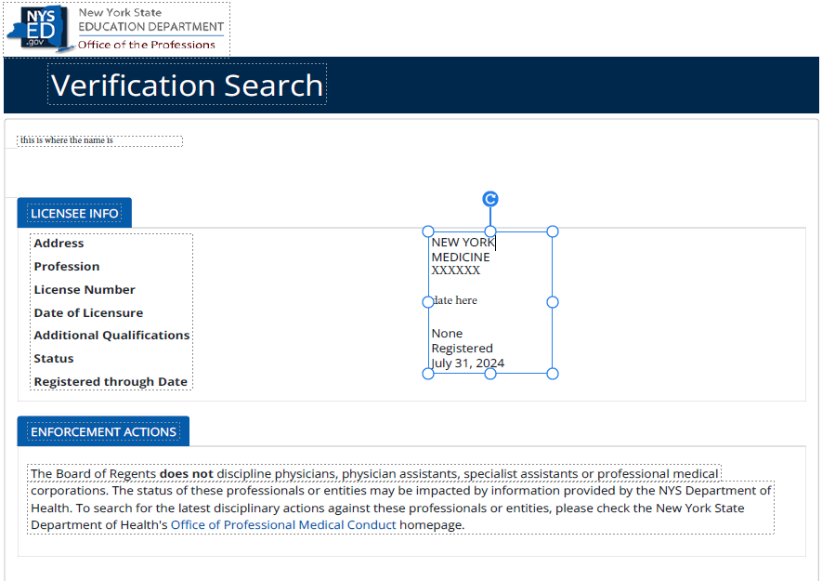
PDF files of a copy of the license(s) is also acceptable.

- A Medical and Technical Staff Roster – Attachment 14 fulfills this requirement.

- Project Services Matrix Form - Attachment 15 fulfills this requirement.

